A Mini Project Report

on

“QUIZ GAME”

Submitted in the partial fulfilment of for the award of

(Bachelor of technology)



**Submitted by**: *Tanya Maheshwari*

Intern

Rapidcode technologies Pvt. Ltd.

**Submitted to:**

Head of Department Project Guide

*Mr. Anand Sharma Mr .Ritesham Shastri*

Managing director

Rapid code technologies Pvt. Ltd.

Department of Information Technology

Aligarh College of Engineering and Technology,

Dr. A.P.J. Abdul Kalam University.

ACKNOWLEDGEMENT

I express my sincere gratitude and thanks to **Rapidcode Technologies Pvt. Ltd**. for providing me the excellent opportunity to do a project on **Quiz GAme** and providing me with all the essential elements required for the completion and enhancement of this project.

I would like to thank those respondents who have taken pain in successful completion of my project work.

UNDERTAKING

My work titled **QUIZ GAME** as part of the Summer Internship (June – July, 2019) under the guidance of Mr. Ritesham Shastri.

If my work has been inspired by anyone else’s work, then all such work(s) has been appropriately referred by me and due acknowledgements have been made.

Any academic misconduct and dishonesty found in regard to above or otherwise shall be solely and entirely my responsibility and my faculty advisor shall not be responsible. In such a situation, I understand that a strict disciplinary action can be undertaken against me by the concerned authorities.

Name: TANYA MAHESHWARI

Date:

Signature:

## **TABLE OF CONTENTS:**

* Introduction
* Idea
* Goals
* System requirement specification
* Feasibility Analysis
* Tools and Utilities
* Project Development
* Design
* Coding

**INTRODUCTION**

This paper gives a summary of my work for the project „Knowledge Island“ of group 15 in the course “Serious Games”. “Knowledge Island” is a role-playing game consisting of a gaming part, which takes place on an island, and a quiz part to increase the knowledge of the player. The goals of the project are to create game, which is fun to play and the player can gain knowledge.

This 'QUIZ GAME' Project is designed for a question in which user can generate and manage a simple database for questions. The question number is automatically generated by the software and is stored in a binary file by the name 'data.txt'. This data base is basically used as a MASTER file to be used as a look-up table for information like Quiz Option, Sub Menu, Computer/Mathematics/Science or General and the Return. It has multiple choice questions and it also calculate scores of each correct answer. It is good for students of every age group it helps in increasing general knowledge about world, Sports and computer etc. Don't need register simply give any user name it will saved automatically and you can login again with same user name and password don’t have to worry about the past score. The application helps the user to increase his/her knowledge. Since Smartphone mobiles are being widely used by general population and students. Quiz Contest system is accessed by entering the user name which is added to the database. Before start of the quiz, the rules and regulations are displayed, number of questions to be answered and scoring methods. Quiz is started by displaying one question with four options each based on computer and general knowledge.

**GOALS**:

There are 4 big goals of the quiz game:

• Motivate the users to create new questions: It is very important that

there are always new interesting questions in the quiz game, otherwise

the quiz will get boring and nobody would like to play it. o Therefore a

ranking with the amount of created questions for each user is displayed

on the start screen. o The player with the most cr eated questions will

get a reward from the management once a year.

• Motivate users to learn: the users should be motivated to gain

knowledge o This is down via a competition between the users,

therefore another ranking with the actual score of each user depending

on the correctly answerd questions is displayed on the start screen.

• Creating new questions should be very fast and easy: When the

developer for example is reading an article about a new technology and

has a good question in his/her mind, then it should be very fast and easy

to create this question in the game. If it is a pain, the user would not

create the question. o Fast startup: There is no login required for playing

the quiz. A login is only required for creating questions, and therefore a

fast login-method is used (e.g. windows logon).

• The game should be fun: The users should like to play the game,

because it is fun: o There is a foto and the nickname of each user

displayed on the screen, so it is more personal and the users like it more

than a usual game. o Players can create funny citations and insider

jokes depending on the day or the user (e.g. “Hey Herbi! Tell me the

answer, thoroughbred software developer!”). This citations and jokes are

presented from the virtual guy “Bill” in the quiz, who is asking the

questions as well.

**MATERIALS AND METHODOLOGY:**

Introduction to C:

C is a procedural programming language. It was initially developed by

Dennis Ritchie between 1969 and 1973. It was mainly developed as a

system programming language to write operating system. The main

features of C language include low-level access to memory, simple set of

keywords, and clean style, these features make C language suitable for

system programming like operating system or compiler development.

Many later languages have borrowed syntax/features directly or indirectly

from C language. Like syntax of Java, PHP, JavaScript and many other

languages is mainly based on C language. C++ is nearly a superset of C

language

.

Features of C Programming Language

* C is a robust language with a rich set of built-in functions and
* operators.
* Programs written in C are efficient and fast.
* C is highly portable, programs once written in C can be run on other machines with minor or no modification.
* C is a collection of C library functions; we can also create our function and add it to the C library.
* C is easily extensible.

**FEASIBILITY** **ANALYSIS**: -

Depending on the results of the initial investigation, the survey is expanded to a more detailed feasibility study. A feasibility study is a test of a system proposal. According to its workability, impact on the organization, ability to meet user’s needs and effective use of the resources its main task done during the feasibility study are: -

* TECHNICAL FEASIBILITY: -

The proposed system is technically feasible as it can be developed easily with the help of available technology. The proposed system requires LINUX – red hat enterprises using VM –ware as Interface for Programming & FILE handling for storing/maintaining database.

* OPERATIONAL FEASIBILITY: -

Automation makes our life easy. The proposed system is highly user friendly and is much easily able to interact with the system. Therefore, the users will readily accept the system as data entry and making queries can be easily done.

**TOOLS AND UTILITIES**: -

***GIT* –**

**Git** is a [distributed version-control](https://en.wikipedia.org/wiki/Distributed_version_control) system for tracking changes in [source code](https://en.wikipedia.org/wiki/Source_code) during [software development](https://en.wikipedia.org/wiki/Software_development). It is designed for coordinating work among [programmers](https://en.wikipedia.org/wiki/Programmer), but it can be used to track changes in any set of [files](https://en.wikipedia.org/wiki/Computer_file). Its goals include speed, [data integrity](https://en.wikipedia.org/wiki/Data_integrity), and support for distributed, non-linear workflows.

Git was created by [Linus Torvalds](https://en.wikipedia.org/wiki/Linus_Torvalds) in 2005 for development of the [Linux kernel](https://en.wikipedia.org/wiki/Linux_kernel), with other kernel developers contributing to its initial development.[[12]](https://en.wikipedia.org/wiki/Git#cite_note-pro-git-1.2-12) Its current maintainer since 2005 is [Junio Hamano](https://en.wikipedia.org/wiki/Junio_Hamano). As with most other distributed version-control systems, and unlike most [client–server](https://en.wikipedia.org/wiki/Client%E2%80%93server) systems, every Git [directory](https://en.wikipedia.org/wiki/Directory_(computing)) on every [computer](https://en.wikipedia.org/wiki/Node_(networking)) is a full-fledged [repository](https://en.wikipedia.org/wiki/Repository_(version_control)) with complete history and full version-tracking abilities, independent of network access or a central server.[[13]](https://en.wikipedia.org/wiki/Git#cite_note-13) Git is [free and open-source software](https://en.wikipedia.org/wiki/Free_and_open-source_software) distributed under the terms of the [GNU General Public License](https://en.wikipedia.org/wiki/GNU_General_Public_License) version 2.

***GDB* –**

A debugger is a program that runs other programs, allowing the user to exercise control over these programs, and to examine variables when problems arise.

GNU Debugger, which is also called **gdb,** is the most popular debugger for UNIX systems to debug C and C++ programs.

GNU Debugger helps you in getting information about the following:

* If a core dump happened, then what statement or expression did the program crash on?
* If an error occurs while executing a function, what line of the program contains the call to that function, and what are the parameters?
* What are the values of program variables at a particular point during execution of the program?
* What is the result of a particular expression in a program?

**PROJECT DEVELOPMENT: -**

**SDLC –**

Software Development Life Cycle (SDLC) is a process used by the software industry to design, develop and test high quality software. The SDLC aims to produce a high-quality software that meets or exceeds customer expectations, reaches completion within times and cost estimates.

* SDLC is the acronym of Software Development Life Cycle.
* It is also called as Software Development Process.
* SDLC is a framework defining tasks performed at each step in the software development process.
* ISO/IEC 12207 is an international standard for software life-cycle processes. It aims to be the standard that defines all the tasks required for developing .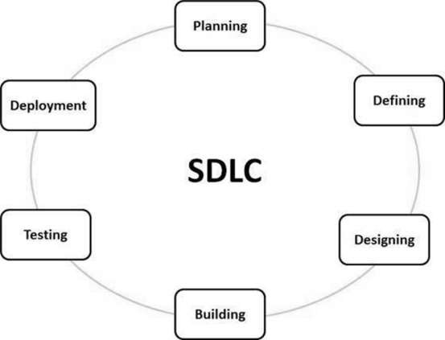

**WATERFALL MODEL:** -

The **waterfall model** is a breakdown of project activities into linear [sequential](https://en.wikipedia.org/wiki/Sequence) phases, where each phase depends on the deliverables of the previous one and corresponds to a specialisation of tasks. The approach is typical for certain areas of [engineering design](https://en.wikipedia.org/wiki/Engineering_design). In [software development](https://en.wikipedia.org/wiki/Software_development_process), it tends to be among the less iterative and flexible approaches, as progress flows in largely one direction ("downwards" like a [waterfall](https://en.wikipedia.org/wiki/Waterfall)) through the initiation, [analysis](https://en.wikipedia.org/wiki/Analysis), [design](https://en.wikipedia.org/wiki/Software_design), [construction](https://en.wikipedia.org/wiki/Software_construction), [testing](https://en.wikipedia.org/wiki/Software_testing), [deployment](https://en.wikipedia.org/wiki/Implementation) and [maintenance](https://en.wikipedia.org/wiki/Software_maintenance).

The waterfall development model originated in the [manufacturing](https://en.wikipedia.org/wiki/Manufacturing) and [construction](https://en.wikipedia.org/wiki/Construction) industries; where the highly structured physical environments meant that design changes became prohibitively expensive much sooner in the development process. When first adopted for software development, there were no recognised alternatives for knowledge-based creative work.

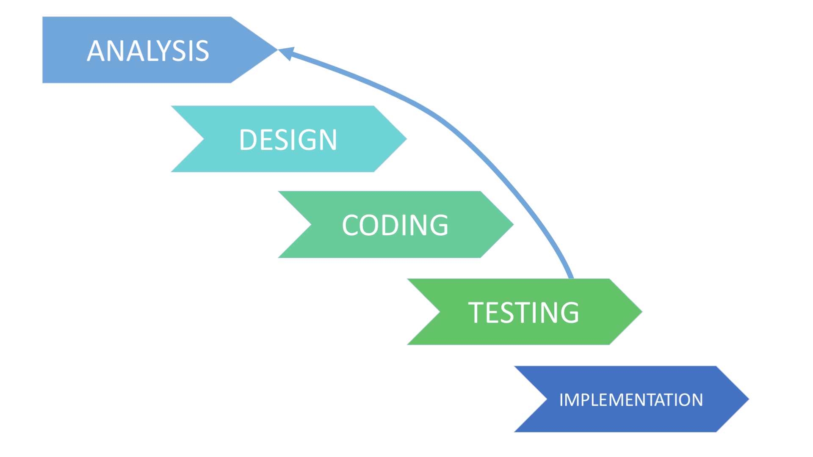

**SYSYTEM REQUIREMENTS**:

* Hardware specifications: -

Hardware is a set of physical components, which performs the functions of applying appropriate, predefined instructions. In other words, one can say that electronic and mechanical parts of computer constitute hardware.

This package is designed on a powerful programming language C. It is a powerful CUI. . It can run on almost all the popular microcomputers. The following are the minimum hardware specifications to run this package: -

Personal Computer: -

It minimum contains P-IV processor

Processor with 512 MB RAM

* Software Requirements**: -**

The software is a set of procedures of coded information or a program which when fed into the computer hardware, enables the computer to perform the various tasks. Software is like a current inside the wire, which cannot be seen but its effect can be felt.

1. Operating System-UNIX/LINUX

2. Application Software: - VM Ware

3. Editor: - vi editor

**DESIGN AND SNAPSHOTS:**

* LOGIN PAGE

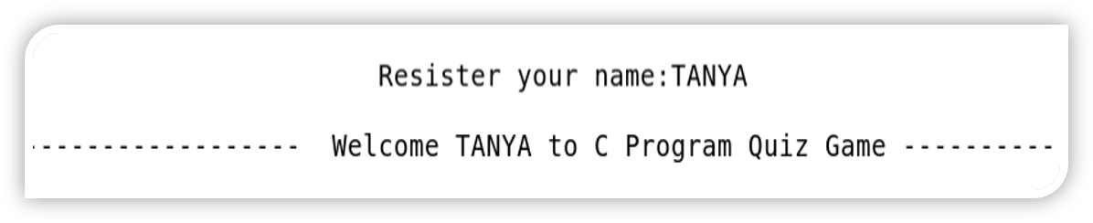

* PLAYING SECTION

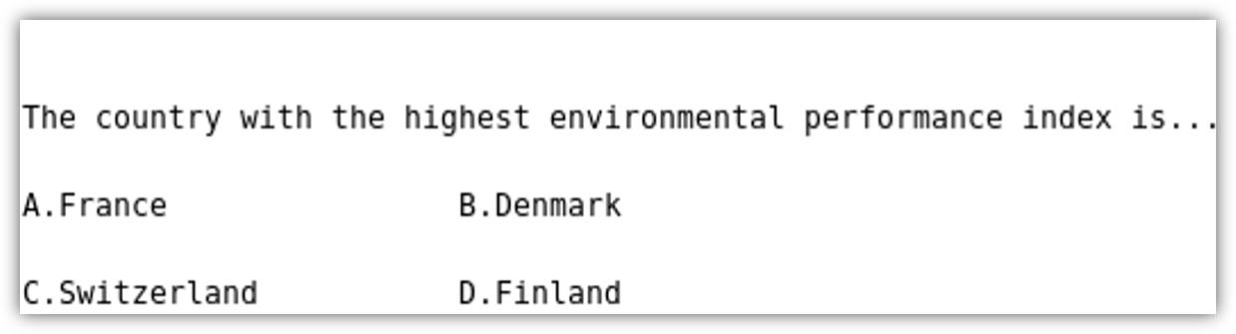

* OPTION SELECTION PAGE

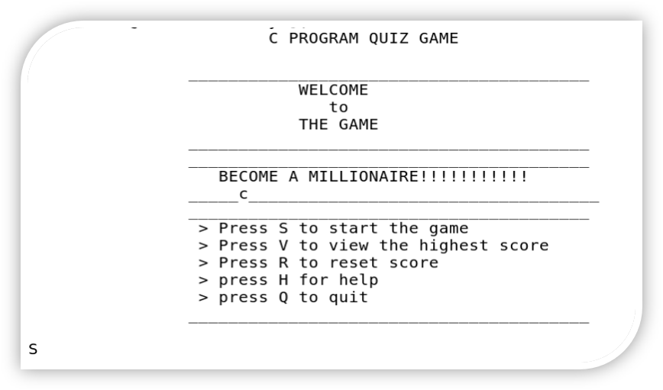

* HELP SECTION

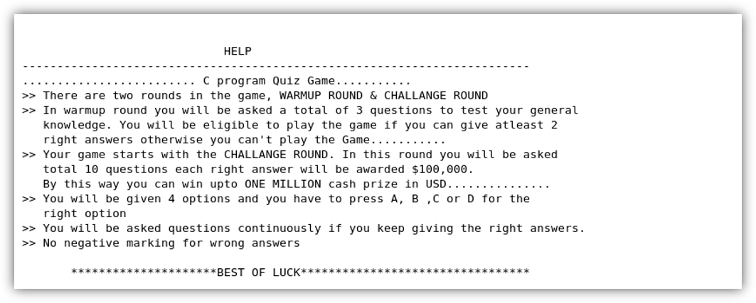

* EXIT PAGE

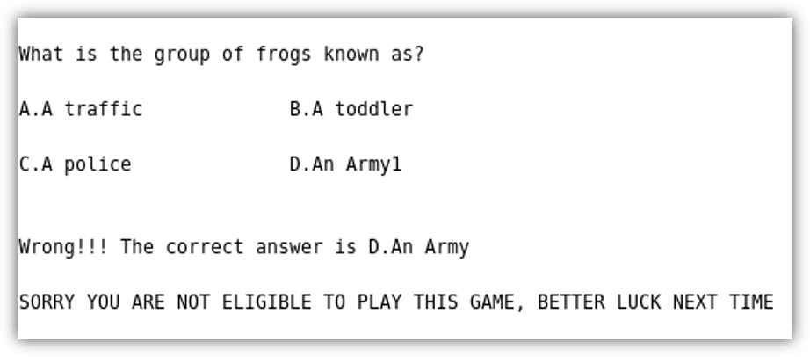

* WINNING PAGE

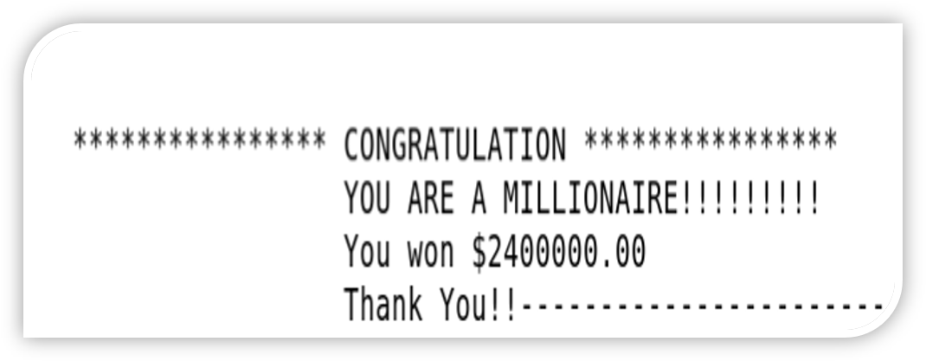

**CODING:**

#include<stdio.h>

#include<ctype.h>

#include<stdlib.h>

#include<string.h>

void show_record();

void reset_score();

void help();

void edit_score(float , char []);

int main()

{

int countr,r,r1,count,i,n;

float score;

char choice;

char playername[20];

mainhome:

system("cls");

printf("\t\t\tC PROGRAM QUIZ GAME\n");

printf("\n\t\t________________________________________");

printf("\n\t\t\t WELCOME ");

printf("\n\t\t\t to ");

printf("\n\t\t\t THE GAME ");

printf("\n\t\t________________________________________");

printf("\n\t\t________________________________________");

printf("\n\t\t BECOME A MILLIONAIRE!!!!!!!!!!! ") ;

printf("\n\t\t________________________________________");

printf("\n\t\t________________________________________");

printf("\n\t\t > Press S to start the game");

printf("\n\t\t > Press V to view the highest score ");

printf("\n\t\t > Press R to reset score");

printf("\n\t\t > press H for help ");

printf("\n\t\t > press Q to quit ");

printf("\n\t\t________________________________________\n\n");

scanf("%c",&choice);

if (choice=='V')

{

show_record();

goto mainhome;

}

else if (choice=='H')

{

help();getch();

goto mainhome;

}

else if (choice=='R')

{reset_score();

getch();

goto mainhome;}

else if (choice=='Q')

exit(1);

else if(choice=='S')

{

system("cls");

printf("\n\n\n\n\n\n\n\n\n\n\t\t\tResister your name:");

gets(playername);

system("cls");

printf("\n ------------------ Welcome %s to C Program Quiz Game --------------------------",playername);

printf("\n\n Here are some tips you might wanna know before playing:");

printf("\n -------------------------------------------------------------------------");

printf("\n >> There are 2 rounds in this Quiz Game,WARMUP ROUND & CHALLANGE ROUND");

printf("\n >> In warmup round you will be asked a total of 3 questions to test your");

printf("\n general knowledge. You are eligible to play the game if you give atleast 2");

printf("\n right answers, otherwise you can't proceed further to the Challenge Round.");

printf("\n >> Your game starts with CHALLANGE ROUND. In this round you will be asked a");

printf("\n total of 10 questions. Each right answer will be awarded $100,000!");

printf("\n By this way you can win upto ONE MILLION cash prize!!!!!..........");

printf("\n >> You will be given 4 options and you have to press A, B ,C or D for the");

printf("\n right option.");

printf("\n >> You will be asked questions continuously, till right answers are given");

printf("\n >> No negative marking for wrong answers!");

printf("\n\n\t!!!!!!!!!!!!! ALL THE BEST !!!!!!!!!!!!!");

printf("\n\n\n Press Y to start the game!\n");

printf("\n Press any other key to return to the main menu!");

//

if (toupper(getch())=='Y')

{

goto home;

}

else

{

goto mainhome;

system("cls");

}

home:

system("cls");

count=0;

for(i=1;i<=3;i++)

{

system("cls");

r1=i;

switch(r1)

{

case 1:

printf("\n\nWhich of the following is a Palindrome number?");

printf("\n\nA.42042\t\tB.101010\n\nC.23232\t\tD.01234");

if (toupper(getch())=='C')

{

printf("\n\nCorrect!!!");count++;

getch();

break;

}

else

{

printf("\n\nWrong!!! The correct answer is C.23232");

getch();

break;

}

case 2:

printf("\n\n\nThe country with the highest environmental performance index is...");

printf("\n\nA.France\t\tB.Denmark\n\nC.Switzerland\t\tD.Finland");

if (toupper(getch())=='C')

{printf("\n\nCorrect!!!");count++;

getch();

break;}

else

{printf("\n\nWrong!!! The correct answer is C.Switzerland");

getch();

break;}

case 3:

printf("\n\n\nWhich animal laughs like human being?");

printf("\n\nA.Polar Bear\t\tB.Hyena\n\nC.Donkey\t\tD.Chimpanzee");

if (toupper(getch())=='B')

{printf("\n\nCorrect!!!");count++;

getch();

break;}

else

{printf("\n\nWrong!!! The correct answer is B.Hyena");

getch();

break;}

case 4:

printf("\n\n\nWho was awarded the youngest player award in Fifa World Cup 2006?");

printf("\n\nA.Wayne Rooney\t\tB.Lucas Podolski\n\nC.Lionel Messi\t\tD.Christiano Ronaldo");

if (toupper(getch())=='B')

{printf("\n\nCorrect!!!");count++;

getch();

break;}

else

{printf("\n\nWrong!!! The correct answer is B.Lucas Podolski");

getch();

break;}

case 5:

printf("\n\n\nWhich is the third highest mountain in the world?");

printf("\n\nA.Mt. K2\t\tB.Mt. Kanchanjungha\n\nC.Mt. Makalu\t\tD.Mt. Kilimanjaro");

if (toupper(getch())=='B')

{printf("\n\nCorrect!!!");count++;

getch();

break;}

else

{printf("\n\nWrong!!! The correct answer is B.Mt. Kanchanjungha");

getch();

break;}

case 6:

printf("\n\n\nWhat is the group of frogs known as?");

printf("\n\nA.A traffic\t\tB.A toddler\n\nC.A police\t\tD.An Army");

if (toupper(getch())=='D' )

{printf("\n\nCorrect!!!");count++;

getch();

break;}

else

{printf("\n\nWrong!!! The correct answer is D.An Army");

getch();

break;}}

}

if(count>=2)

{goto test;}

else

{

system("cls");

printf("\n\nSORRY YOU ARE NOT ELIGIBLE TO PLAY THIS GAME, BETTER LUCK NEXT TIME");

getch();

goto mainhome;

}

test:

system("cls");

printf("\n\n\t*** CONGRATULATION %s you are eligible to play the Game ***",playername);

printf("\n\n\n\n\t!Press any key to Start the Game!");

if(toupper(getch())=='p')

{goto game;}

game:

countr=0;

for(i=1;i<=10;i++)

{system("cls");

r=i;

switch(r)

{

case 1:

printf("\n\nWhat is the National Game of England?");

printf("\n\nA.Football\t\tB.Basketball\n\nC.Cricket\t\tD.Baseball");

if (toupper(getch())=='C')

{printf("\n\nCorrect!!!");countr++;getch();

break;getch();}

else

{printf("\n\nWrong!!! The correct answer is C.Cricket");getch();

goto score;

break;}

case 2:

printf("\n\n\nStudy of Earthquake is called............,");

printf("\n\nA.Seismology\t\tB.Cosmology\n\nC.Orology\t\tD.Etimology");

if (toupper(getch())=='A')

{printf("\n\nCorrect!!!");countr++;getch();

break;}

else

{printf("\n\nWrong!!! The correct answer is A.Seismology");getch();

goto score;

break;

}

case 3:

printf("\n\n\nAmong the top 10 highest peaks in the world, how many lie in Nepal? ");

printf("\n\nA.6\t\tB.7\n\nC.8\t\tD.9");

if (toupper(getch())=='C')

{printf("\n\nCorrect!!!");countr++;getch();

break;}

else

{printf("\n\nWrong!!! The correct answer is C.8");getch();

goto score;

break;}

case 4:

printf("\n\n\nThe Laws of Electromagnetic Induction were given by?");

printf("\n\nA.Faraday\t\tB.Tesla\n\nC.Maxwell\t\tD.Coulomb");

if (toupper(getch())=='A')

{printf("\n\nCorrect!!!");countr++;getch();

break;}

else

{

printf("\n\nWrong!!! The correct answer is A.Faraday");getch();

goto score;

break;

}

case 5:

printf("\n\n\nIn what unit is electric power measured?");

printf("\n\nA.Coulomb\t\tB.Watt\n\nC.Power\t\tD.Units");

if (toupper(getch())=='B')

{printf("\n\nCorrect!!!");countr++;getch(); break;}

else

{

printf("\n\nWrong!!! The correct answer is B.Power");

getch();

goto score;

break;

}

case 6:

printf("\n\n\nWhich element is found in Vitamin B12?");

printf("\n\nA.Zinc\t\tB.Cobalt\n\nC.Calcium\t\tD.Iron");

if (toupper(getch())=='B' )

{printf("\n\nCorrect!!!");countr++;getch();

break;}

else

{printf("\n\nWrong!!! The correct answer is B.Cobalt");goto score;

getch();

break;}

case 7:

printf("\n\n\nWhat is the National Name of Japan?");

printf("\n\nA.Polska\t\tB.Hellas\n\nC.Drukyul\t\tD.Nippon");

if (toupper(getch())=='D')

{printf("\n\nCorrect!!!");countr++;getch();

break;}

else

{printf("\n\nWrong!!! The correct answer is D.Nippon");getch();

goto score;

break;}

case 8:

printf("\n\n\nHow many times a piece of paper can be folded at the most?");

printf("\n\nA.6\t\tB.7\n\nC.8\t\tD.Depends on the size of paper");

if (toupper(getch())=='B')

{printf("\n\nCorrect!!!");countr++;getch(); break;}

else

{printf("\n\nWrong!!! The correct answer is B.7");getch();

goto score;

break;}

case 9:

printf("\n\n\nWhat is the capital of Denmark?");

printf("\n\nA.Copenhagen\t\tB.Helsinki\n\nC.Ajax\t\tD.Galatasaray");

if (toupper(getch())=='A')

{printf("\n\nCorrect!!!");countr++; getch();

break;}

else

{printf("\n\nWrong!!! The correct answer is A.Copenhagen");getch();

goto score;

break;}

case 10:

printf("\n\n\nWhich is the longest River in the world?");

printf("\n\nA.Nile\t\tB.Koshi\n\nC.Ganga\t\tD.Amazon");

if (toupper(getch())=='A')

{printf("\n\nCorrect!!!");countr++;getch(); break;}

else

{printf("\n\nWrong!!! The correct answer is A.Nile");getch();break;goto score;}

case 11:

printf("\n\n\nWhat is the color of the Black Box in aeroplanes?");

printf("\n\nA.White\t\tB.Black\n\nC.Orange\t\tD.Red");

if (toupper(getch())=='C')

{printf("\n\nCorrect!!!");countr++;getch();

break;}

else

{printf("\n\nWrong!!! The correct answer is C.Orange");getch();

break;goto score;}

case 12:

printf("\n\n\nWhich city is known at 'The City of Seven Hills'?");

printf("\n\nA.Rome\t\tB.Vactican City\n\nC.Madrid\t\tD.Berlin");

if (toupper(getch())=='A')

{printf("\n\nCorrect!!!");countr++;getch();

break;}

else

{printf("\n\nWrong!!! The correct answer is A.Rome");getch();

break;goto score;}

case 13:

printf("\n\n\nName the country where there no mosquitoes are found?");

printf("\n\nA.Japan\t\tB.Italy\n\nC.Argentina\t\tD.France");

if (toupper(getch())=='D')

{printf("\n\nCorrect!!!");countr++;getch();

break;}

else

{printf("\n\nWrong!!! The correct answer is D.France");getch();

break;goto score;}

case 14:

printf("\n\n\nWho is the author of 'Pulpasa Cafe'?");

printf("\n\nA.Narayan Wagle\t\tB.Lal Gopal Subedi\n\nC.B.P. Koirala\t\tD.Khagendra Sangraula");

if (toupper(getch())=='A')

{printf("\n\nCorrect!!!");countr++;getch();

break;}

else

{printf("\n\nWrong!!! The correct answer is A.Narayan Wagle");getch();

break;goto score;}

case 15:

printf("\n\n\nWhich Blood Group is known as the Universal Recipient?");

printf("\n\nA.A\t\tB.AB\n\nC.B\t\tD.O");

if (toupper(getch())=='B')

{printf("\n\nCorrect!!!");countr++;getch();

break;}

else

{printf("\n\nWrong!!! The correct answer is B.AB");getch();

goto score;

break;}

case 16:

printf("\n\n\nWhat is the unit of measurement of distance between Stars?");

printf("\n\nA.Light Year\t\tB.Coulomb\n\nC.Nautical Mile\t\tD.Kilometer");

if (toupper(getch())=='A')

{printf("\n\nCorrect!!!");countr++; getch();

break;

}

else

{printf("\n\nWrong!!! The correct answer is A.Light Year");getch();

goto score;

break;}

case 17:

printf("\n\n\nThe country famous for Samba Dance is........");

printf("\n\nA.Brazil\t\tB.Venezuela\n\nC.Nigeria\t\tD.Bolivia");

if (toupper(getch())=='A')

{printf("\n\nCorrect!!!");countr++; getch();

break;}

else

{printf("\n\nWrong!!! The correct answer is A.Brazil");getch();goto score;

break;}

case 18:

printf("\n\n\nWind speed is measure by__________?");

printf("\n\nA.Lysimeter\t\tB.Air vane\n\nC.Hydrometer\t\tD.Anemometer\n\n");

if (toupper(getch())=='D')

{printf("\n\nCorrect!!!");countr++; getch();

break;}

else

{printf("\n\nWrong!!! The correct answer is D.Anemometer");getch();goto score;

break;}

case 19:

printf("\n\n\nWhich city in the world is popularly known as The City of Temple?");

printf("\n\nA.Delhi\tB.Bhaktapur\n\nC.Kathmandu\tD.Agra\n\n");

if (toupper(getch())=='C')

{printf("\n\nCorrect!!!");countr++; getch();

break;}

else

{printf("\n\nWrong!!! The correct answer is C.Kathmandu");getch();goto score;

break;}

case 20:

printf("\n\n\nWhich hardware was used in the First Generation Computer?");

printf("\n\nA.Transistor\t\tB.Valves\n\nC.I.C\t\tD.S.S.I");

if (toupper(getch())=='B')

{printf("\n\nCorrect!!!");countr++; getch();

break;}

else

{printf("\n\nWrong!!! The correct answer is B.Valves");getch();goto score;

break;}

case 21:

printf("\n\n\nOzone plate is being destroyed regularly because of____ ?");

printf("\n\nA.L.P.G\t\tB.Nitrogen\n\nC.Methane\t\tD. C.F.C");

if (toupper(getch())=='D')

{printf("\n\nCorrect!!!");countr++; getch();

break;}

else

{printf("\n\nWrong!!! The correct answer is D. C.F.C");getch();goto score;

break;}

case 22:

printf("\n\n\nWho won the Women's Australian Open Tennis in 2007?");

printf("\n\nA.Martina Hingis\t\tB.Maria Sarapova\n\nC.Kim Clijster\t\tD.Serena Williams");

if (toupper(getch())=='D')

{printf("\n\nCorrect!!!");countr++; getch();

break;}

else

{printf("\n\nWrong!!! The correct answer is D.Serena Williams");getch();goto score;

break;}

case 23:

printf("\n\n\nWhich film was awarded the Best Motion Picture at Oscar in 2010?");

printf("\n\nA.The Secret in their Eyes\t\tB.Shutter Island\n\nC.The King's Speech\t\tD.The Reader");

if (toupper(getch())=='C')

{printf("\n\nCorrect!!!");countr++; getch();

break;}

else

{printf("\n\nWrong!!! The correct answer is C.The King's Speech");getch();goto score;

break;}}}

score:

system("cls");

score=(float)countr*100000;

if(score>0.00 && score<1000000)

{

printf("\n\n\t\t**************** CONGRATULATION *****************");

printf("\n\t You won $%.2f",score);goto go;}

else if(score==1000000.00)

{

printf("\n\n\n \t\t**************** CONGRATULATION ****************");

printf("\n\t\t\t\t YOU ARE A MILLIONAIRE!!!!!!!!!");

printf("\n\t\t You won $%.2f",score);

printf("\t\t Thank You!!");

}

else

{

printf("\n\n\t******** SORRY YOU DIDN'T WIN ANY CASH ********");

printf("\n\t\t Thanks for your participation");

printf("\n\t\t TRY AGAIN");goto go;}

go:

puts("\n\n Press Y if you want to play next game");

puts(" Press any key if you want to go main menu");

if (toupper(getch())=='Y')

goto home;

else

{

edit_score(score,playername);

goto mainhome;}}}

void show_record()

{system("cls");

char name[20];

float scr;

FILE *f;

f=fopen("score.txt","r");

fscanf(f,"%s%f",&name,&scr);

printf("\n\n\t\t*************************************************************");

printf("\n\n\t\t %s has secured the Highest Score %0.2f",name,scr);

printf("\n\n\t\t*************************************************************");

fclose(f);

getch();}

void reset_score()

{system("cls");

float sc;

char nm[20];

FILE *f;

f=fopen("score.txt","r+");

fscanf(f,"%s%f",&nm,&sc);

sc=0;

fprintf(f,"%s,%.2f",nm,sc);

fclose(f);}

void help()

{system("cls");

printf("\n\n HELP");

printf("\n -------------------------------------------------------------------------");

printf("\n ......................... C program Quiz Game...........");

printf("\n >> There are two rounds in the game, WARMUP ROUND & CHALLANGE ROUND");

printf("\n >> In warmup round you will be asked a total of 3 questions to test your general");

printf("\n knowledge. You will be eligible to play the game if you can give atleast 2");

printf("\n right answers otherwise you can't play the Game...........");

printf("\n >> Your game starts with the CHALLANGE ROUND. In this round you will be asked");

printf("\n total 10 questions each right answer will be awarded $100,000.");

printf("\n By this way you can win upto ONE MILLION cash prize in USD...............");

printf("\n >> You will be given 4 options and you have to press A, B ,C or D for the");

printf("\n right option");

printf("\n >> You will be asked questions continuously if you keep giving the right answers.");

printf("\n >> No negative marking for wrong answers");

printf("\n\n\t*********************BEST OF LUCK*********************************");

printf("\n\n\t*****C PROGRAM QUIZ GAME is developed by CODE WITH C TEAM********");}

void edit_score(float score, char plnm[20])

{system("cls");

float sc;

char nm[20];

FILE *f;

f=fopen("score.txt","r");

fscanf(f,"%s%f",&nm,&sc);

if (score>=sc)

{ sc=score;

fclose(f);

f=fopen("score.txt","w");

fprintf(f,"%s\n%.2f",plnm,sc);

fclose(f);}}

**BIBLIOGRAPHY AND REFERENCES:**

BOOK: - EXPLORING –C, THE C PROGRAMMING LANGUAGE

WEBSITES: - [WWW.RAPIDCODE.COM](http://WWW.RAPIDCODE.COM)

SEARCH ENGINES: - YAHOO, MSN, GOOGLE etc.